**Chapter 2**

**Limits**

**2.2 The Limit of a Function**

**Section Exercises**

**For the following exercises, consider the function** 

31. What do your results in the preceding exercise indicate about the two-sided limit ? Explain your response.

Answer:  does not exist because .

**For the following exercises, consider the function .**

33. What does the table of values in the preceding exercise indicate about the function?

Answer: 

**In the following exercises, use the given values to set up a table to evaluate the limits. Round your solutions to eight decimal places.**

35. **[T]** ; ±0.1, ±0.01, ±0.001, ±.0001

|  |  |  |  |
| --- | --- | --- | --- |
| ***x*** |  | ***x*** |  |
| –0.1 | a. | 0.1 | e. |
| –0.01 | b. | 0.01 | f. |
| –0.001 | c. | 0.001 | g. |
| –0.0001 | d. | 0.0001 | h. |

Answer: a. 1.98669331; b. 1.99986667; c. 1.99999867; d. 1.99999999; e. 1.98669331; f. 1.99986667; g. 1.99999867; h. 1.99999999; 

37. Use the preceding two exercises to conjecture (guess) the value of the following limit:  for *a*, a positive real value.

Answer: 

**[T] In the following exercises, set up a table of values to find the indicated limit. Round to eight digits.**

39. 

|  |  |  |  |
| --- | --- | --- | --- |
| ***x*** |  | ***x*** |  |
| 0.9 | a. | 1.1 | e. |
| 0.99 | b. | 1.01 | f. |
| 0.999 | c. | 1.001 | g. |
| 0.9999 | d. | 1.0001 | h. |

Answer: a. –0.80000000; b. –0.98000000; c. –0.99800000; d. –0.99980000; e. –1.2000000; f. –1.0200000; g. –1.0020000; h. –1.0002000; 

41. 

|  |  |  |  |
| --- | --- | --- | --- |
| ***z*** |  | ***z*** |  |
| –0.1 | a. | 0.1 | e. |
| –0.01 | b. | 0.01 | f. |
| –0.001 | c. | 0.001 | g. |
| –0.0001 | d. | 0.0001 | h. |

Answer: a. –37.931934; b. –3377.9264; c. –333,777.93; d. –33,337,778; e. –29.032258; f. –3289.0365 ; g. –332,889.04; h. –33,328,889 

43. 

|  |  |  |  |
| --- | --- | --- | --- |
| ***x*** |  | ***x*** |  |
| 1.9 | a. | 2.1 | e. |
| 1.99 | b. | 2.01 | f. |
| 1.999 | c. | 2.001 | g. |
| 1.9999 | d. | 2.0001 | h. |

Answer: a. 0.13495277; b. 0.12594300; c. 0.12509381; d. 0.12500938; e. 0.11614402; f. 0.12406794; g. 0.12490631; h. 0.12499063; ]

**[T] In the following exercises, set up a table of values and round to eight significant digits. Based on the table of values, make a guess about what the limit is. Then, use a calculator to graph the function and determine the limit. Was the conjecture correct? If not, why does the method of tables fail?**

45. 

|  |  |
| --- | --- |
| ***a*** |  |
| 0.1 | a. |
| 0.01 | b. |
| 0.001 | c. |
| 0.0001 | d. |

Answer: a. –10.00000; b. –100.00000; c. –1000.0000; d. –10,000.000; Guess: , actual: DNE

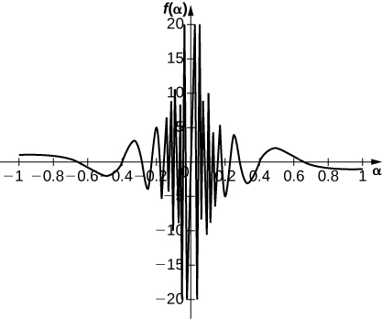

**In the following exercises, consider the graph of the function  shown here. Which of the statements about  are true and which are false? Explain why a statement is false**.

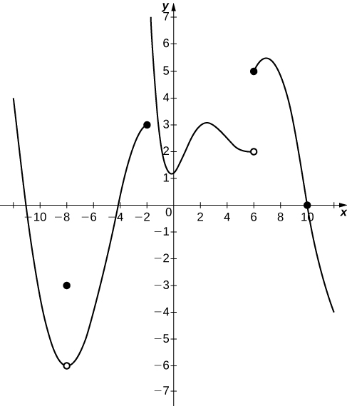

47. 

Answer: False; 

49. 

Answer: False;  DNE since  and .

**In the following exercises, use the following graph of the function  to find the values, if possible. Estimate when necessary.**

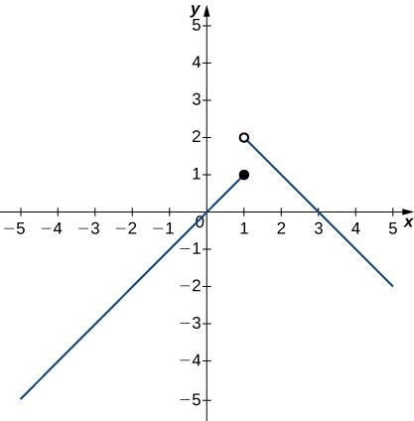

51. 

Answer: 2

53. 

Answer: 1

**In the following exercises, use the graph of the function  shown here to find the values, if possible. Estimate when necessary.**

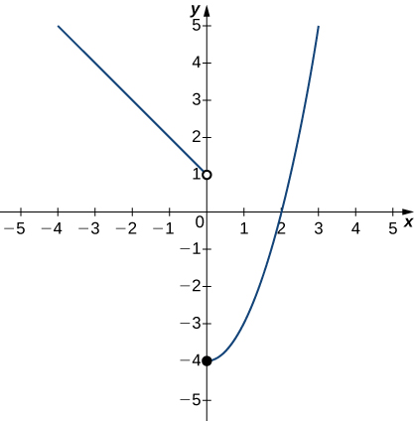

55. 

Answer: 1

57. 

Answer: DNE

**In the following exercises, use the graph of the function  shown here to find the values, if possible. Estimate when necessary.**

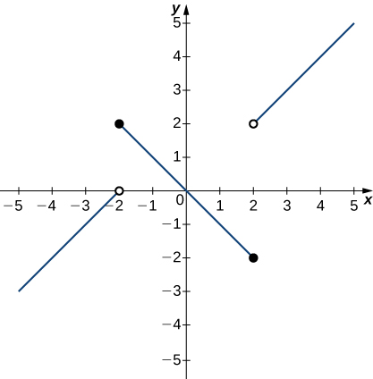

59. 

Answer: 0

61. 

Answer: DNE

63. 

Answer: 2

**In the following exercises, use the graph of the function  shown here to find the values, if possible. Estimate when necessary.**

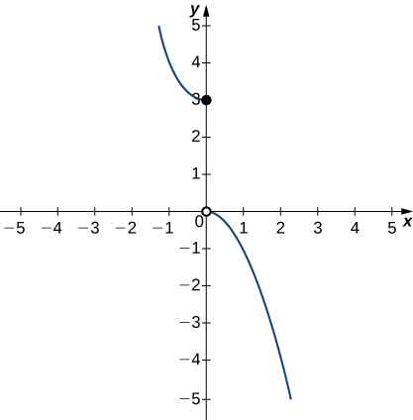

65. 

Answer: 3

67. 

Answer: DNE

**In the following exercises, use the graph of the function  shown here to find the values, if possible. Estimate when necessary.**

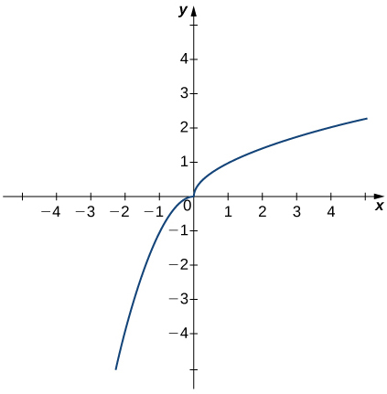

69. 

Answer: 0

**In the following exercises, use the graph of the function  shown here to find the values, if possible. Estimate when necessary.**

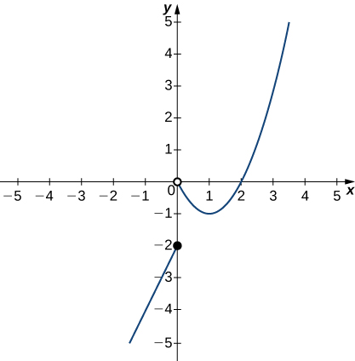

71. 

Answer: –2

73. 

Answer: DNE

75. 

Answer: 0

**In the following exercises, sketch the graph of a function with the given properties.**

77. , , , , , 

Answer: Answers may vary.

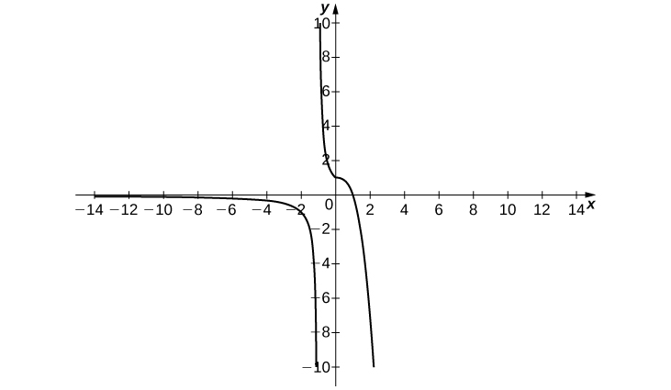

79. , , , 

Answer: Answers may vary.

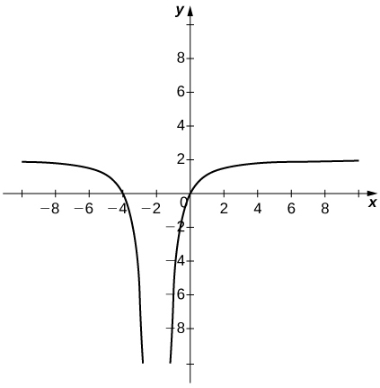

81. Shock waves arise in many physical applications, ranging from supernovas to detonation waves. A graph of the density of a shock wave with respect to distance, *x*, is shown here. We are mainly interested in the location of the front of the shock, labeled  in the diagram.

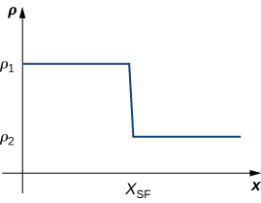

1. Evaluate
2. Evaluate
3. Evaluate. Explain the physical meanings behind your answers.

Answer: a.  b.  c. DNE unless . As you approach  from the right, you are in the high-density area of the shock. When you approach from the left, you have not experienced the “shock” yet and are at a lower density.

This file is copyright 2016, Rice University. All Rights Reserved.